I like / I don’t like to play soccer.  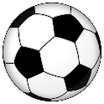 | I like / I don’t like to play tennis.   | I like / I don’t like to play golf.  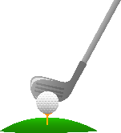 | I like / I don’t like to go running/jogging.  
I like / I don’t like to play baseball.  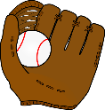 | I like / I don’t like to play badminton.  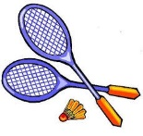 | I like / I don’t like to play volleyball.  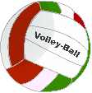 | I like / I don’t like to go biking.  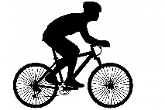
I like / I don’t like to play basketball.  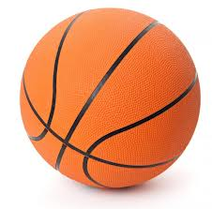 | I like / I don’t like to go swimming.  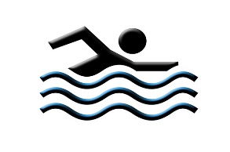 | I like / I don’t like to play hockey.  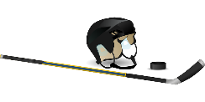 | I like / I don’t like to practise boxing.  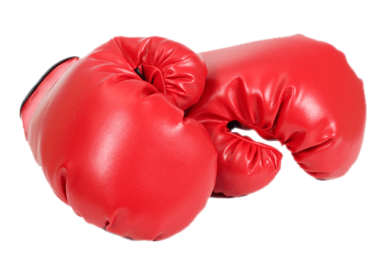
I like / I don’t like to play football.  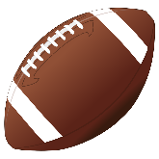 | I like / I don’t like to do gymnastics.  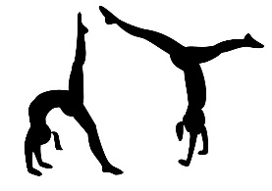 | I like / I don’t like to do martial arts.  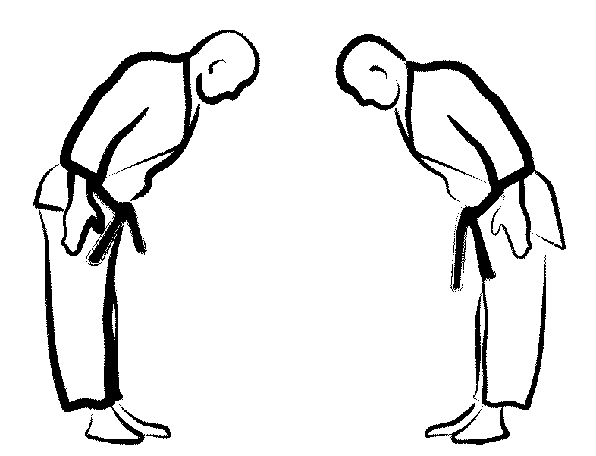 | I like / I don’t like to go skiing.  