Stuck at home because of Covid 19
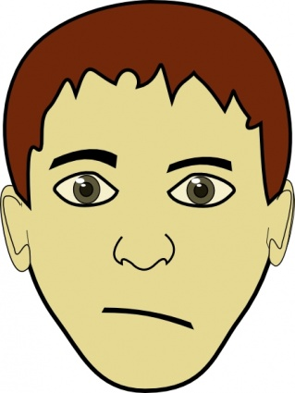
Hello, I’m Rosie. I’m 12 years old and I live in a flat in London. Staying at home is a bit boring, but it’s better than going to school. I get up late and I play video games. My mum is a key worker – she is a nurse, so she has to go to work. I keep the flat clean and tidy. In the afternoon, I do school work. The teachers check up on me, so I have to do it. I stretch my legs by walking round the block of flats for about an hour. I keep away from everybody else, obviously.
Answer: Yes, she is/No, she isn’t. Yes, she does/No, she doesn’t
- Does Rosie live in Manchester?
- Is she 12 years of age?
- Does she think isolation is fun?
- Does she watch TV in the morning?
- Is her mum a key worker?
- Does she do her schoolwork in the afternoon?
- Does she do the housework?
- Does she take some exercise for one hour a day?
Hi, my name is Jack and I am ____.
I really ___ my friends, that’s the worst
thing about having to stay at ___! I kind
of miss school as well. I like school and I am trying to keep __ with my school work. The teachers ___ us lots of stuff and it’s really good. I enjoy carrying out research ___. I have two brothers. They are both younger ___ me. We don’t usually play together, but we do ___! We have a kickabout every afternoon in the ___. Normally, my dad doesn’t let us play football in the garden, but, well, times are very ____ now, aren’t they? In the evening, we play video games or ____ a bit of TV. It’s not too bad at the ___, but I hope we get back to normal soon!
Replace the words: tasks, garden, watch, now, than, miss, home, up, send, different, moment, thirteen



Hiya, I’m Anna and I’m not happy! I’m 16, in year 11 and my exams are cancelled! I’m not saying I like exams, I don’t. But this means my teachers will estimate my marks and …well, I don’t always work hard. So now, I don’t have the chance to revise at the last minute and do well in my exams. It’s tough! I will go back to school to study ‘A’ levels in September. In the meantime, I am chilling; on my social media lot and hiding in my
bedroom. My mum keeps asking me to help with the housework and I hate housework! The worst thing is I really miss my friends! Life is so unfair! This coronavirus thing sucks;-(
- Why is Anna not happy?
- How will her GCSE marks be awarded?
- What is she doing at home?
- Why is she hiding in her bedroom a lot?
- What does she miss the most?
How do, my name is William. I’m fourteen. These days, I get up at 10 or 10:30, play video games for about an hour and then I log on to do my school work. I spend a couple of hours on that. Most of it is boring, but there’s not much else to do. Both my parents are working from home, online, and that sometimes means that the connection is really slow. I have two sisters and sometimes, we are all online together, then the connection times out. Luckily, there is a big field at the back of our house and I can go out for a kickabout. There’s one or two other kids out as well, but we keep away from each other. One good thing is we all sit down together for our evening meal and have a good chat.
Answer True or false: Correct the false sentences:
1. William gets up early.
2. He plays video games till 2pm
3. They have problems with the internet
4. There are other kids around, but he keeps away
from them.
5. The family dine separately in the evening.


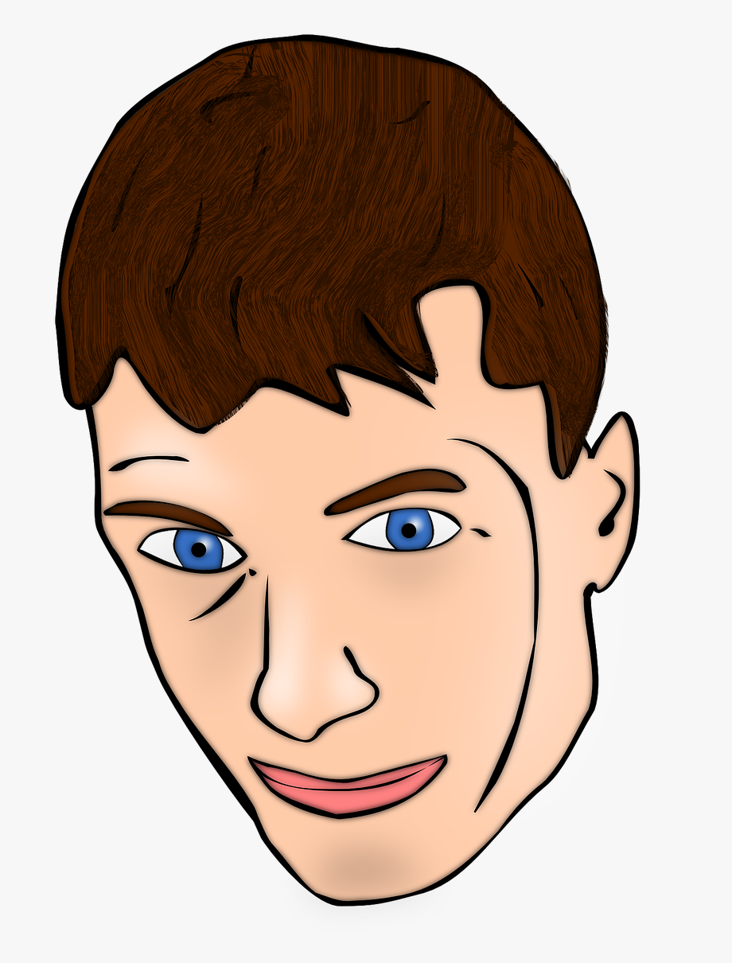


Hi, I’m Mark! I’m _____.
I’ve got ____hair and blue
eyes. I’m ____ my red
T-shirt, jeans and _____.
I’ve got my computer, my ___
and my mobile phones, so I’m
OK about this _____. I’m
_____ in touch with all
my friends and I’m always
_____ on my social media
sites. I do all my schoolwork
every afternoon; I ____ about
two ____ on it and this is
enough. I live in a flat with
my mum and our ____. This
will be ____ soon; it’s not
too bad.
Replace the missing words
Answer the questions.
- What time do you get up, these days?
- How long do you spend playing video games?
- How long do you spend doing school work?
- What is the quality of the work your teachers are sending? Could they do better or are they making a good job of it?
- Are you able to do some exercise every day? Describe the exercise you take.
- Are you learning anything new?
- Are you reading any good books?
- What do you miss most about school?
- Are you getting on well with other family members, or are there tensions?
- Is there anything you could do to be more helpful at home?
- Is there anything you can do to make sure this lockdown time works out OK for you?

blond, seventeen, trainers, tablet, lockdown, posting, spend, cat, over, wearing, hours, keeping

Key: Rosie: 1. No, she doesn’t. 2.Yes, she is. 3. No, she doesn’t. 4. No, she doesn’t. 5. Yes, she is. 6. Yes, she does. 7. Yes, she does. 8. Yes, she does.
Jack. Thirteen, miss, home, up, send, tasks, than, now, garden, different, watch, moment.
Anna. 1. Because her exams are cancelled. 2. They will be marked by the teachers. The teachers will estimate her marks. 3. She is chilling. 4. Because her mum wants her to do housework, and she hates that. 5. She misses her friends the most.
William: 1F, 2F, 3T, 4T 5F
Mark: seventeen, blond, wearing, trainers. tablet, lockdown, keeping, posting, spend, hours, cat, over.

GRADE 6
READ THE TEXTS AND ANSWER THE QUESTIONS BELOW
Hi, my name is Darwin Watterson, I’m ten years old and I live in Elmore. I go to school from Monday to Friday but when I’m not at school I practice sports. My favorite sports are adventure sports, especially water sports. I practice white-water rafting, kayaking and canyoning.
I always go kayaking on Monday and on Wednesday. When I finish school and after I finish my homework I take my kayak and I go to the beach with my friend Tobias. On Tuesday and on Thursday I go white-water rafting. You need a group to do white-water rafting, it is difficult but it is really exciting. I go canyoning on Friday afternoon. Canyoning is my favorite sport; you have to go down a river canyon using your hands, legs and some ropes. You need some special equipment to practice canyoning; you need a helmet to protect your head, a wetsuit not to feel cold, ropes and harness to go down the canyon. Finally, I take a rest on the weekend to play some videogames with my brother, Gumball. He doesn’t like practicing sports.

Hello, I’m Skips, I’m 300 years old and I live in the park. I have to work every day of the week, from Monday to Sunday, but, when I finish my work I have a lot of free time. In my free time I like to practice sports. I personally prefer adventure sports because those are risky. I like parachuting, bungee jumping and rock climbing.
I usually go rock climbing on Saturday or Sunday afternoon, I normally go on my own. I like climbing mountains and the solitude when you reach the top of the mountain; if you want to go climbing you need to be very strong. I go bungee jumping on Friday afternoon. You need to be very brave to jump of a cliff with just a rope attached to your feet. Finally, I have to say that my favorite sport is parachuting; I love parachuting. I always go parachuting on Thursday but, I never go at night, I always go in the morning. Parachuting is when you jump off a plane with a parachute on your back, you open it during the fall and you land gently on the floor after a couple of minutes. It feels like you were flying and I love that feeling. I went once with Mordecai but he got scared and he didn’t jump. Do you want to try parachuting? You need to be very brave.

1. What are Darwin’s favorite sports?
2. When does he go kayaking?
3. When does he go canyoning?
4. What special equipment do you need to practice canyoning?
5. What does he do on the weekend?
6. What are Skips’ favorite sports?
7. Does he go rock climbing on Friday?
8. What special quality you need to go climbing?
9. Does he go parachuting at night?
10. Did Mordecai like parachuting

