**Grade 5**

Anglais, langue seconde

Needs and Wants

Consigne à l’élève

Do you use all your toys? Do you wear all your clothes?

Sometimes we buy things and we don’t end up using them.

It is important to take a moment to reflect before spending money on something.

Today we will learn the difference between needs and wants.

1. Read the definitions.
2. In the first chart, indicate whether each item is a need or a want.

DEFINITIONS

|  |
| --- |
| A **need** is something you cannot live without.  For example: I need water to stay alive. |

|  |
| --- |
| A **want** is something you are interested in having. You **can live** without it.  For example: I want a new smartphone to call my friends. |

FIRST CHART

|  |  |  |
| --- | --- | --- |
| Do you need or want these items? | NEED | WANT |
| Example, water | **X** |  |
| Electricity |  |  |
| Food |  |  |
| A television |  |  |
| A guitar |  |  |
| A new toy |  |  |
| A toothbrush |  |  |
| Candies |  |  |
| A home |  |  |

Look at the following acrostic poem model.

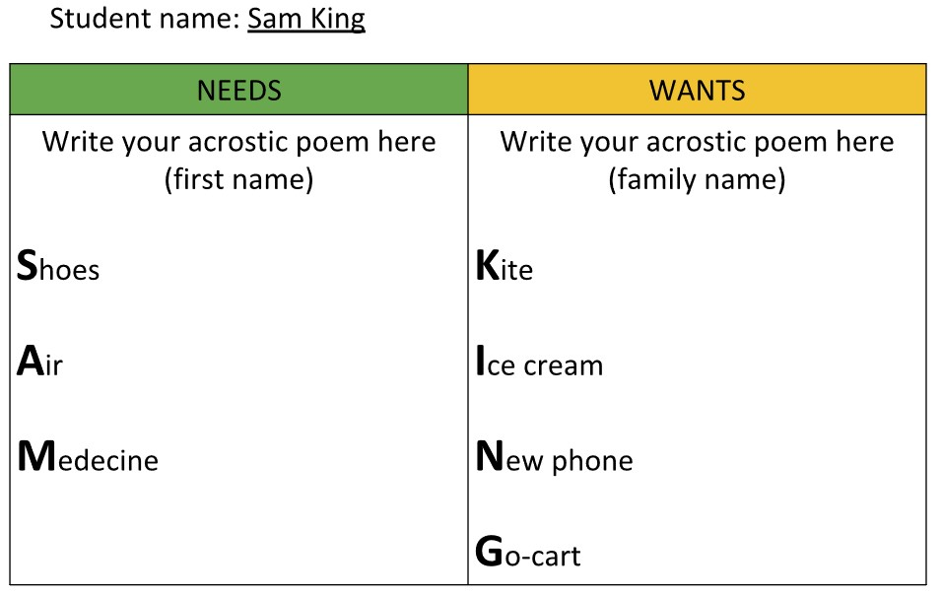

My acrostic poem

Write your first name vertically in the first column.

Write your family name vertically in the second column.

Left-hand side: Needs / Right-hand side: Wants

*Use picture dictionaries to find vocabulary words as needed.

|  |  |
| --- | --- |
| NEEDS | WANTS |
| Write your acrostic poem here (**first name**) | Write your acrostic poem here (**family name**) |

Click [here](https://www.opdome.com/)  for a picture dictionary.

**Press** ‘**CTRL**’ of your keyboard and **click** on the image.

[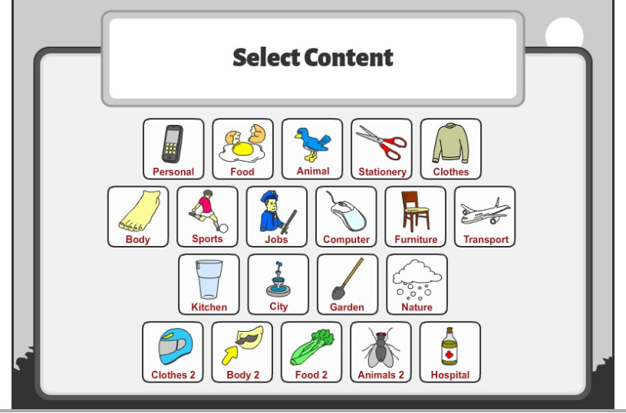](https://www.opdome.com/)

Adapted by Eddy Peh.

Source : Activité proposée par Dianne Elizabeth Stankiewicz, (Commission scolaire de la Beauce-Etchemin), Bonny-Ann Cameron, (Commission scolaire de la Capitale), Émilie Racine, (Commission scolaire de Portneuf), et Lisa Vachon, (Commission scolaire des Appalaches), conseillères pédagogiques.

Anglais, langue seconde

**Grade 6**

Green Gifts

Consigne à l’élève

There are many occasions every year for us to receive or give presents. Be it a celebration of any kind, we are always looking for the perfect gift that will please our loved ones.

Today we will learn more about what makes a gift meaningful and find ideas for future gifts.

1. Make a list of five gifts you have received in the past.

|  |  |
| --- | --- |
| **1.** |  |
| **2.** |  |
| **3.** |  |
| **4.** |  |
| **5.** |  |

1. Highlight the gifts that you use regularly.

What do you notice? Do you use them frequently?

__________________________________________________

__________________________________________________

1. Read the statements below.

Indicate if you agree or disagree with the statements.

|  |  |  |
| --- | --- | --- |
| **Statements** | **I**  **agree** | **I**  **disagree** |
| Gifts have to be expensive ($$$) to be cool. |  |  |
| I am happy only if I receive a gift on my birthday. |  |  |
| I always like and use the gifts I receive. |  |  |
| I would be happy if someone offered me homemade cookies for my birthday. |  |  |
| I think homemade gifts are the best. |  |  |
| I sometimes make gifts for my friends and family. |  |  |
| Taking someone to the movies is a great gift idea. |  |  |

1. Look at the [interactive image](https://view.genial.ly/5e9df4bd8695b90d873ae10f/interactive-image-image-interactive).

Click on each icon to read the text.

Read the text carefully.

**Press** ‘**CTRL**’ of your keyboard and **click** on the image.

[](https://view.genial.ly/5e9df4bd8695b90d873ae10f/interactive-image-green-gifts)

1. Read the name on each category.

For each category, write down four green gifts ideas.

|  |  |  |
| --- | --- | --- |
| **Homemade food** | **Activities** | **Crafts** |
| Cookies | Going to the movies | Picture frame |
|  |  |  |
|  |  |  |
|  |  |  |
|  |  |  |
| **Second-hand items** | **Service** | **Other ideas** |
| Books | Taking the dog out | Homemade board game |
|  |  |  |
|  |  |  |
|  |  |  |
|  |  |  |

**Suggestions:**

**Option 1:**

Survey family members and friends to find out about the best green gift they ever received.

**Option 2:**

Create a card for your mom to celebrate Mother’s Day, a card for a family member or for a friend.

**Example 1**

Draw your own card.

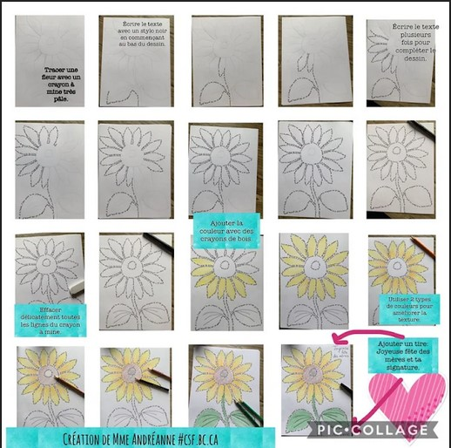

**Example 2**

Use an online program to print a card.

**Press ‘CTRL’** of your keyboard and **click** on the link.

<https://wordart.com/create>

1. Type in the **words**. For example, Happy 12th Birthday!
2. Choose **shapes** and **fonts**.
3. Click on ‘**Visualize**’ to see card.
4. Click ‘**Print**’ to print the card.

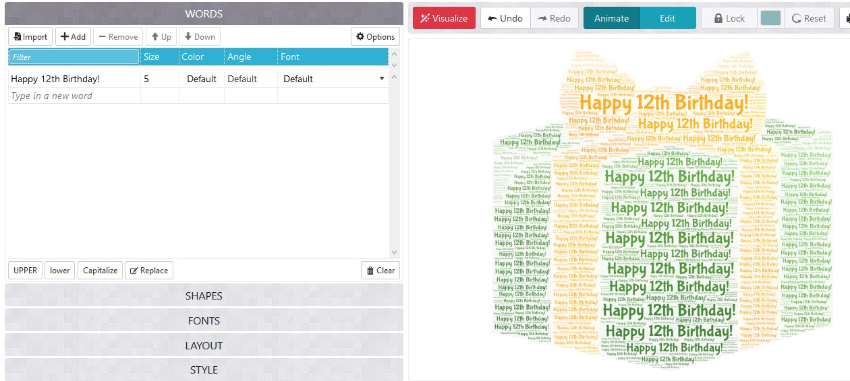

Adapted by Eddy Peh.

Source : Activité proposée par Dianne Elizabeth Stankiewicz, (Commission scolaire de la Beauce-Etchemin), Bonny-Ann Cameron, (Commission scolaire de la Capitale), Émilie Racine, (Commission scolaire de Portneuf), et Lisa Vachon, (Commission scolaire des Appalaches), conseillères pédagogiques.